Teleoperation with Sensor/Actuator Asymmetry:
Task Performance with Partial Force Feedback

Wagahta Semere, Masaya Kitagawa, and Allison M. Okamura
Department of Mechanical Engineering

The Johns Hopkins University
Baltimore, MD 21218
wsemere@stanford.edu, {mkitagawa, aokamura}@jhu.edu

Abstract

For practical application of force feedback in robot-assisted surgical systems, it may not be possible to match the number of degrees of freedom of position sensing and control with the degrees of freedom of force sensing and feedback. The goal of this experimental study is to determine the effect of such sensor/actuator asymmetry during bilateral telemanipulation. We examined the performance of two tool-based teleoperated tasks: (1) a task to push a cup through a series of poses and (2) a blunt dissection task using phantom tissues. Three different force feedback conditions were applied to a 3-D teleoperation system: (1) 3-D force feedback, (2) force feedback without the axial forces measured on the slave tool, and (3) no force feedback. The tasks were also performed manually using a hand-held stylus. Results show that the absence of measured axial forces does not create a statistically significant difference in the level of applied forces, in comparison with complete 3-D force feedback. In addition, this partial force feedback is a significant improvement over teleoperation with no force feedback.

1. Introduction

The discovery of minimally invasive techniques has redefined surgical practice. Both surgeons and their patients can appreciate the potential benefits of less blood loss, decreased complication rates, lower costs, and shorter hospital stays. Despite these advantages, it is estimated that only one-fourth of the 15 million surgeries performed each year are classified as minimally invasive [1]. The increasing realization of minimally invasive approaches has not come without limitations. Surgeons are often restricted by a lack of adequate precision with standard endoscopic instruments as well as an unstable operative view. In the field of cardiac surgery, these shortcomings have become particularly noticeable during minimally invasive direct coronary artery bypass grafting procedures [2]. The difficulty in accessing anastomotic targets has reduced the surgeon’s precision and may be attributed to limited visualization as well as hand tremor [3]. Growing interest in minimally invasive procedures across surgical disciplines has, however, inspired the development of robotic assistance in the operating room to address these technical challenges.
Teleoperated robotic surgical systems are rapidly gaining popularity in the surgical community. These computer-based control systems allow surgeons to remotely operate instruments located within the patient. By digitizing the surgeon’s movements to isolate and remove high frequency oscillating motions, the computer is able to effectively remove hand tremor. Additionally, the computer system is able to actively scale the surgeon’s movements and convert them to a microscopic motion at the instrument tips. Worldwide, thousands of general surgical and several hundred cardiac surgical procedures have been performed with teleoperated robotic surgical systems. The da Vinci Surgical System from Intuitive Surgical, Inc. (Mountain View, CA) has been used in cardiac surgery to perform coronary artery bypass grafting and mitral valve repair. Despite the many advantages of having computer-assistance while operating, many surgeons have noted the lack of haptic (force and tactile) feedback as a significant limitation. Although cardiac surgeons have successfully performed robot-assisted procedures, they have found them to be generally more time consuming than conventional open operations. Additionally, training for basic laparoscopic tasks has proven to be significantly slower with robotic assistance [4]. Our recent work has shown that haptic feedback is critical to the precision and accuracy of force applied during suture ties [5].
There are, however, several technical challenges to consider when designing haptic feedback for teleoperation systems. We are particularly concerned with the design and placement of force sensors on a slave manipulator, and providing appropriate force feedback to the master, given limited sensing capability. The cost of a sensing system is important, since the interchangeable tools on a system such as the da Vinci are disposable after a dozen uses. An inexpensive method proposed for measuring force near the distal tip of a minimally invasive tool is to attach sets of strain gauges to the tool shaft and measure bending forces [6]. This sensing method is not able to measure forces along the axis of the shaft, so only 2-D force vectors can be measured. This creates an asymmetric sensor/actuator system [7], in which the number of degrees of freedom of force feedback is different from the number of degrees of freedom of position control. The goal of this work is to quantify the performance of operators during execution of two 3-D teleoperated tasks, while providing different degrees of freedom of force feedback. The tasks are (1) a task to push a cup through a series of poses and (2) a blunt dissection task using phantom tissues.

  - Previous Work

Previous studies examining the role of force feedback in teleoperation systems have examined the levels and type of information provided to the user. A significant amount of this work has been devoted to analysis of performance in simple motion tasks outside the realm of surgery [8,9]. Of those studies considering a surgical environment, few have dealt with manipulating soft tissues, which accounts for 25-35% of the time spent on most surgical procedures [10]. In a recent analysis of blunt dissection, Wagner, et. al examined the magnitude of force applied under varying percentages of force feedback gain with a 3-degree-of-freedom bilateral teleoperation system. Wagner found that the absence of force feedback increased the average force magnitude applied to the tissue by at least 50% and increased the peak force magnitude by at least a factor of 2, suggesting that force feedback was helpful in preventing the damage of tissue [11]. Using a signal from a strain-gauge sensor, Sabatini, et. al conducted preliminary work to determine the forces applied to soft tissue when users were provided with visual feedback. The results of Sabatini’s work suggested the benefits of improved performance with force feedback [12].
Although it has been proven that force feedback enhances a user’s ability to control forces applied to the robot during teleoperation task performance, none of these studies have observed the effect of missing certain degrees of freedom of force feedback. Barbagli and Salisbury considered the case of haptic interfaces allowing users more degrees of motion than force feedback. An asymmetric system, when lacking force feedback in one axis, was found to lead to energetically unfavorable interactions in a virtual environment [7]. Motivated by this study, we have created an asymmetric teleoperation system in which the slave robot lacks sufficient degrees of freedom of force sensing to match the degrees of freedom of position control. Considering the limitations of the strain gauge sensing system, we have chosen to eliminate force feedback along the axis of the attached robot end tool.

2. Experiments

With sensor/actuator asymmetry, ideal telepresence cannot be achieved. In our experiments, the combination of motion of the slave and loss of axial force sensing on the slave tool causes the force applied to the operator to change direction, even when the forces applied to the environment remain constant in a global coordinate system. It is important to note that the loss of a degree of freedom of force sensing occurs in the tool coordinate system, so forces in a global (stationary) coordinate system applied to the operator can still be in 3-D. This effect is quite noticeable during manipulation tasks, and experimental investigation is required to determine whether it generates a statistically significant degradation in performance when compared to manual or 3-D force feedback.

  - Hypotheses

The experiments were designed with three hypotheses under consideration:
Hypothesis 1 (No Axial Force Feedback = Full Force Feedback): The magnitude of force applied without axial force feedback closely approximates the magnitude of force applied under full force feedback conditions. In addition, there is no statistically significant difference between absence of axial force feedback and full force feedback, when considering time to complete the cup-pushing task or length of artery dissected for the blunt dissection task.
Hypothesis 2 (No Axial Force Feedback ≠ No Force Feedback): The magnitude of force applied using partial force feedback differs significantly from the amount of force applied without feedback. There is also a statistically significant difference for time to complete the cup-pushing task and length of artery dissected during blunt dissection.
Hypothesis 3 (Full Force Feedback = Manual): The magnitude of force applied using the robot with full force feedback closely approximates the magnitude of force applied manually, given similar degrees of freedom in movement. Additionally, the time to complete the cup pushing task and length of artery dissected under full force feedback closely approximates the manual condition.

  - Teleoperation System

The teleoperation system used for the experiments consists of two PHANTOM haptic interface devices (Models Premium 1.0 and 1.5, SensAble Technologies, Inc., Woburn, Massachusetts) controlled by the same computer, a six-axis force/torque sensor (Nano-17, ATI Industrial Automation, Apex, North Carolina), a digital video camera, and computer monitor (Figure 1). In our setup, the 1.5 PHANTOM acts as the master, controlling the motions of a 1.0 PHANTOM slave. The master provides the operator with 3 degrees of freedom of position measurement and force feedback, and a passive gimbal is used to generate an additional 3 degrees of freedom of orientation to a stylus grasped by the operator. The slave has only 3 degrees of freedom for position control and force output. The stylus was removed from the slave to allow insertion of a force sensor and task-specific tool.
The ATI six-axis force/torque sensor measures forces applied at the tip of the tool. Using a rod attachment, the sensor is inserted into the slave shaft; the experiment tools are similarly mounted to the opposite end of the sensor. Operators control the motion of the slave robot, with an end-tool attached, by moving the master stylus.
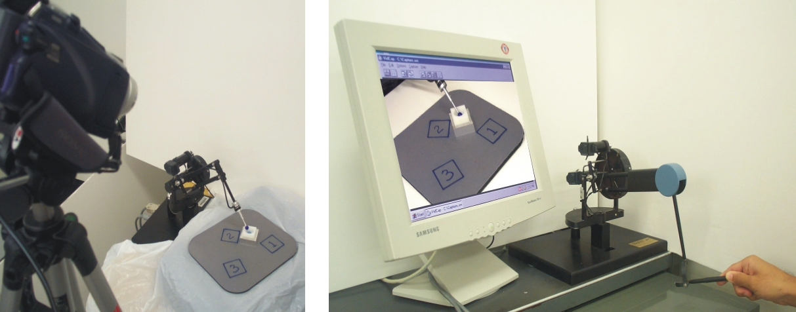

Figure 1. Experimental setup for teleoperation tasks using two PHANTOM haptic interfaces.
The motions of the slave robot and a view of the task are captured by a digital video camera; this image is displayed under fixed magnification on a 17in flat screen computer monitor placed directly in front of the operator.

  - Experiment Design

The experiment was divided into two parts to examine performance of surgical and non-surgical tasks under 4 force feedback conditions: (1) manual, (2) full force feedback, (3) no tool axis force feedback, and (4) no force feedback. The order of these trials was randomized among subjects for each task. For the manual trials, subjects used a stylus with the force sensor attached above the tool to perform the task under direct vision of the task set-up. Using the rod, subjects were able to have the same degrees of freedom in movement as when manipulating the master stylus. For the teleoperated trials, subjects used the master robot stylus to control the movements of the tool mounted on the slave; during these trials, subjects watched a magnified digital video camera image on the computer monitor in front of them.
Ten subjects, 8 males and 2 females, performed the experiments; one subject was left-handed. Six of the subjects had no experience using any teleoperation system and were considered to be novices. The mean age of the study participants was 27.4 years.

  - Experiment 1: Cup-pushing

The first part of the experiment tested performance of a non-surgical task with the four types of force feedback. For this test scenario, subjects carried out a sequence of cup-pushing moves. Subjects were asked to move a cup (a rectangular block with a 20-mm diameter half sphere removed from the top surface) lying on the table from a starting pose to an intermediate pose and then a final pose. A ball-end-rod tool was used to push the cup between locations. The ball had a 10mm diameter and the rod had a length of 3mm. The target locations were drawn on a surface beneath the cup and labeled 1, 2 and 3, for the starting, intermediate, and final poses (Figure 2). Before moving to the next pose, subjects were required to accurately position the cup in the depicted location. Subjects were instructed to move to each location as quickly as possible. An accurate pose was identified when the marked boundary was visible on at least two sides of the cup, and the cup was within 2mm of the boundary.
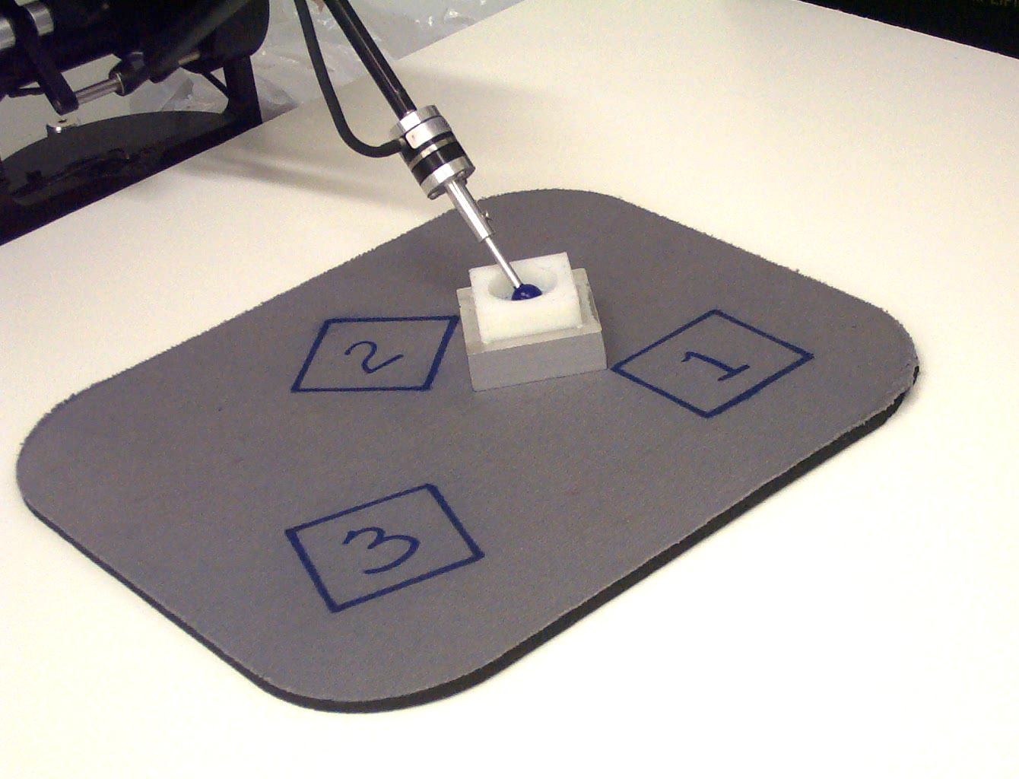

Figure 2. Experiment 1, the cup-pushing task. The tool and PHANTOM are connected by a multi-axis force sensor.

Subjects practiced performing the task with the different types of force feedback for approximately 10 minutes. Each subject completed their four trials given unlimited time, but with the instruction that they should aim to complete the trial as quickly as possible.

  - Experiment 2: Blunt Dissection

The second experiment tested performance of a surgical task with the four types of force feedback. Each subject performed this set of trials at least one week and no more than two weeks after completing the cup-pushing experiments. Subjects were instructed to expose an “artery” from a soft “tissue” bed using a 1 mm tip diameter blunt dissection hook (Dandy Nerve Hook, Surgical 911). The concept of the surgical model and exposure procedure closely follows that used in the Wagner’s experimental analysis of blunt dissection [11].
The surgical model simulates an artery embedded in tissue. The artery is created from a cylindrical mold 4mm in diameter and 10cm in length. Surrounding tissue covers the artery, extending 13mm on each of its sides and 1mm above the top surface (Figure 3). Polyvinyl chloride (Super Soft Plastic, M-F Manufacturing, Texas) was chosen to model the artery and phthalate ester (Softener, M-F Manufacturing, Texas) was added to vary elasticity for the surrounding tissue. The material is intended to simulate the properties of real tissue.
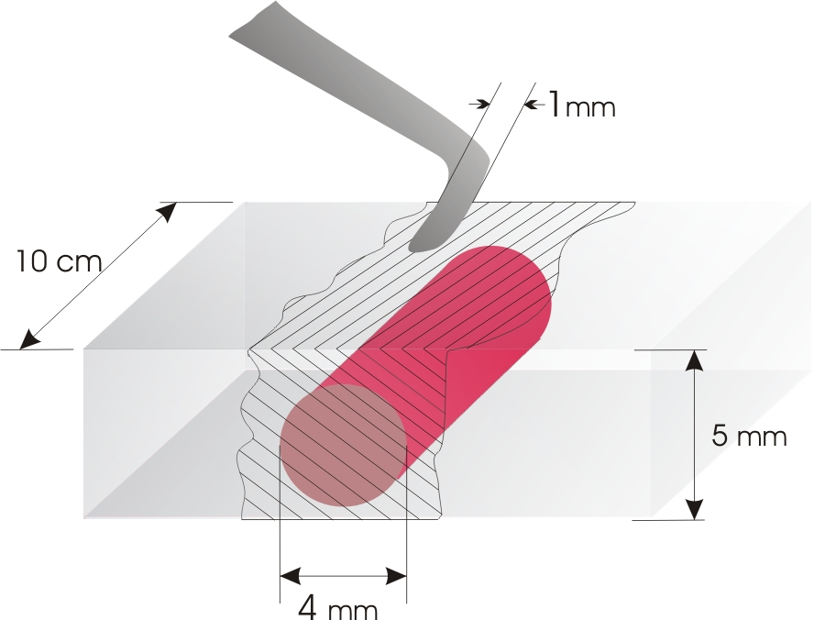

Figure 3. Geometry of the artery and tissue model for the blunt dissection task.

Subjects were instructed to expose the artery by clearing away any connecting tissue on each side of the artery as well as removing any tissue on top of the artery. The duration of each trial was fixed and subjects were instructed to expose as much of the artery as possible in the allotted time. The subject began dissection at the designated top of the artery mold and progressed downward, working to clear both the sides and the top of the artery at the same time. The red artery was visible to the user through the translucent surrounding tissue and lay straight in the center of the surgical model for every trial (Figure 4). Subjects trained for approximately 15 minutes on a practice surgical model, using each type of force feedback during this practice. Each subject performed 4 dissection trials, lasting 2 minutes each, under the varying force feedback conditions.
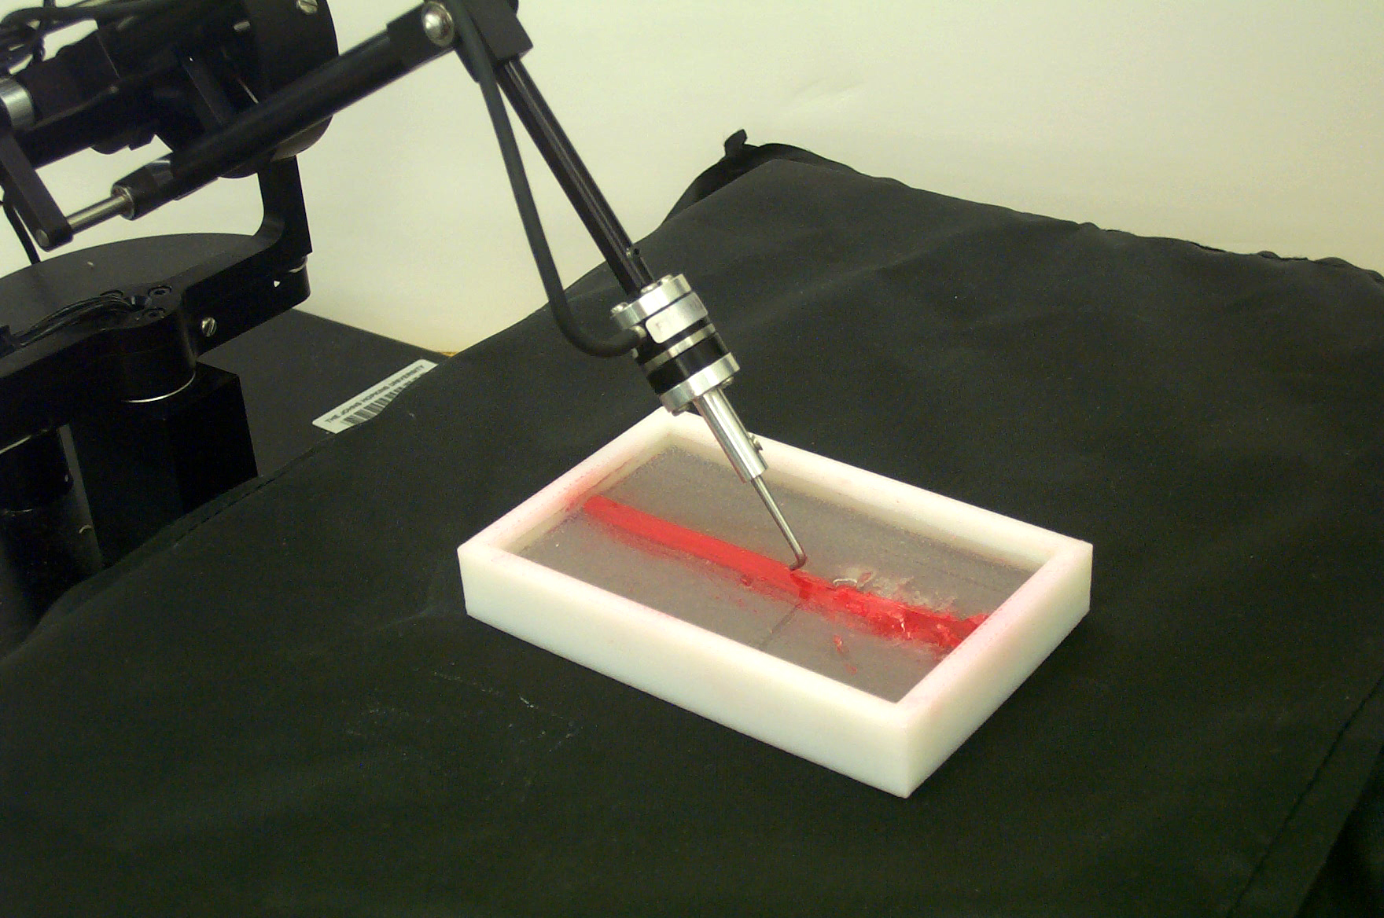

Figure 4. Experiment 2, the blunt dissection task.

  - Statistical Analysis

For each of the three hypotheses, first the analysis of variance (ANOVA) test for a single factor repeated measures design was used to determine significance of difference in variables of interest. Comparison of these variables between subjects was then determined by employing Tukey’s test at a 95% confidence level. The data of interest included the root-mean-square (RMS) forces, the peak forces, the duration of each trial for the cup-pushing task, and the length of artery exposed during the blunt dissection trials.

3. Results

Hypothesis 1 (Full Force Feedback = No Axial Force Feedback): The first hypothesis proposes that the magnitude of force applied without axial force feedback closely approximates the magnitude of force applied under the full force feedback condition. Figure 5 shows the average RMS and peak forces for the cup-pushing and blunt dissection trials. Tukey’s test was employed with a confidence level of 95% to test the hypothesis for RMS force and peak force values. For both tasks, there was no statistically significant difference found. Hypothesis 1 additionally states that there is no statistically significant difference between full force feedback and no axial force feedback, when considering time to complete the cup-pushing task or length of artery dissected for the blunt dissection task. There was no statistically significant difference found in the duration of the cup-pushing trials or length of artery dissected between the two force feedback conditions (Figures 6 and 7). These findings indicate that the no axial force feedback condition approximates full force feedback, when considering the magnitude of force applied and speed/length performance metrics. Hypothesis 1 is therefore validated.
Hypothesis 2 (No Axial Force Feedback ≠ No Force Feedback): The second hypothesis proposes that the magnitude of force applied using the no axial force feedback method differs significantly from the amount of force applied without feedback. Figures 8 and 9 show the average force magnitude applied by subjects plotted against time for each force feedback trial during the experiment tasks. Subjects spent more time applying high levels of force when completing tasks without force feedback. In contrast, when some force feedback was available, subjects spent less time applying high levels of force. A significant difference was found between the average RMS and peak forces for no axial force feedback and no force feedback, verifying the graphical observation and part of Hypothesis 2. The second hypothesis also states that there is a statistically significant difference between axial force feedback and no feedback for time to complete the cup-pushing task and length of artery dissected during blunt dissection. There was no a statistically significant difference found between no axial force feedback and no feedback in cup-pushing completion time or length of blunt dissection. Thus, hypothesis 2 is not completely satisfied. These results suggest that significantly higher forces are applied without any force feedback than with partial force feedback, but the speed/length of task execution is not different.
Hypothesis 3 (Full Force Feedback = Manual): Hypothesis 3 proposes that the magnitude of force applied using the robot with full force feedback closely approximates the magnitude of force applied manually, given similar degrees of freedom in movement. There was no significant difference found between average RMS and peak forces applied manually and with full force feedback. Hypothesis 3 additionally stated that the time to complete the cup pushing task and length of artery dissected under full force feedback closely approximates the manual condition. The performance speed for completion of both tasks under full force feedback conditions was not found to be significantly different from the time required to complete the tasks manually. These findings verify that full force feedback closely approximates manual execution of tasks tested, in terms of the magnitude of forces applied and execution speed, thereby validating Hypothesis 3.
Figure 5. Average RMS and peak forces for the cup-pushing and blunt dissection experiments under different force feedback conditions.
Figure 6. Average duration of the cup-pushing trials under different force feedback conditions.

Figure 7. Average length of exposed artery for the blunt dissection experiment under different force feedback conditions.

Figure 8. Average force magnitude applied during the cup-pushing experiment.

Figure 9. Average force magnitude applied during the blunt dissection experiment.

4. Discussion and Conclusions

The goal of this study was to examine the effect of varying degrees-of-freedom of force feedback on the performance of manipulation tasks using a teleoperation system. We formulated several hypotheses to determine the effect of asymmetric teleoperation systems. All of the hypotheses were partially satisfied for both tasks in that peak force and RMS force without axial force feedback closely approximated performance with full force feedback. Furthermore, there was a difference (less average peak force and RMS force) in magnitude of applied forces when comparing no feedback to any force feedback. These findings suggest an improvement in subject performance by minimizing the use of excessive force to complete a task. In a surgical environment, applying higher levels of force than required to complete a task might prove detrimental to delicate tissues.
The hypotheses also propose that the application of any force feedback to the user would shorten the cup-pushing task completion time and increase the length of artery dissected within the fixed time frame, but this was not found to be true. There was no significant difference found between the task completion time and the length of artery dissected, across the varying force feedback conditions. This finding suggests that efficiency (in terms of force or energy expenditure), but not overall speed, improved with force feedback. Successful execution of delicate surgical procedures, such as the manipulation of soft tissue modeled in our experiment, are more likely to depend on efficiency as opposed to speed.
These results are promising evidence that simple force sensing systems can be used to create bilateral telemanipulation systems that improve surgical performance. As described earlier, an inexpensive method for measuring force at the tip of a shaft (such as an endoscopic tool) is to attach a pair of strain gauges to each side and measure bending forces. This type of feedback neglects the forces along the axis of the shaft, thereby only providing the user with 2-D feedback. This study provides the first statistically significant data indicating that teleoperation with a 2-D force sensing device would result in performance comparable to a system with full (3-D) force feedback, which in turn closely approximates the natural feedback from manually holding an instrument.
Future experimental studies will aim to study surgical tasks that involve additional degrees of freedom, including gripping forces. Furthermore, data would be better verified by the inclusion of surgeons as subjects and the eventual use of real surgical test beds. In an analytical approach, we are planning to model the energetic effects of sensor/actuator asymmetry and develop control laws to maintain system passivity.

Acknowledgments

The authors acknowledge Chad Schneider, Todd Murphy and Robert Webster (Johns Hopkins University) for their assistance in fabrication of the experiment materials and Chris Wagner (Harvard University) for his advice on experimental procedure. David D. Yuh, M.D. (Johns Hopkins Cardiac Surgery Division) provided guidance regarding surgical applications. This material is based on work supported by the National Science Foundation under grant EEC-9731478.

References

[1] D. Gerhardus, “Robot-Assisted Surgery: The Future Is Here,” Journal of Healthcare Management, Vol. 48, No. 4, pp. 242-251, 2003.
[2] E. R. Stephenson, S. Sankholkar, C.T. Ducko, and R. J. Damiano, “Robotically Assisted Microsurgery for Endoscopic Coronary Artery Bypass Grafting,” The Annals of Thoracic Surgery, Vol. 66, No. 3, pp. 1064-1067, 1998.
[3] S. Pagni, N. Qaqish, D.G. Senior, and P.A. Spence, “Anastomotic Complications in Minimally Invasive Coronary Bypass Grafting,” The Annals of Thoracic Surgery, Vol.63, pp. S64-S67, 1997.
[4] S. M. Prasad, H. S. Maniar, N. J. Soper, R. J. Damiano, and M. E. Klingensmith, “The Effect of Robotic Assistance on Learning Curves for Basic Laparoscopic Skills,” The American Journal of Surgery, Vol. 183, No. 6, pp. 702-707, 2002.
[5] M. Kitagawa, A. M. Okamura, B. T. Bethea, V. L.Gott, and W. A. Baumgartner, “Analysis of Suture Manipulation Forces for Teleoperation with Force Feedback,” Proc. Fifth International Conference on Medical Image Computing and Computer Assisted Intervention -- MICCAI 2002, Lecture Notes in Computer Science (Vol. 2488), T. Dohi and R. Kikinis, Eds., pp. 155-162, 2002.
[6] S. Prasad, M. Kitagawa, G. S. Fischer, J. Zand, M. A. Talamini, R. H. Taylor, and A. M. Okamura, "A Modular 2-DOF Force-Sensing Instrument For Laparoscopic Surgery." Submitted to the Sixth International Conference on Medical Image Computing and Computer Assisted Intervention – MICCAI 2003.
[7] F. Barbagli and K. Salisbury, “The Effect of Sensor/Actuator Asymmetries in Haptic Interfaces,” Proceedings, 11th Symposium on Haptic Interfaces for Virtual Environment and Teleoperator Systems--HAPTICS 2003, pp. 140-147, 2003.
[8] C. G. L. Cao, C. L. MacKenzie, and S. Payandeh, “Task and Motion Analyses in Endoscopic Surgery,” Proc. Symposium on Haptic Interfaces for Virtual Environment and Teleoperator Systems, ASME DSC, Vol. 58, pp. 583-590, 1996.
[9] M. J. Massimino and T. B. Sheridan, “Sensory Substitution for Force Feedback in Teleoperation,” IFAC Symposia Series, No. 5, pp. 109-114, 1993.
[10] C. E. H. Scott-Conner, The SAGES Manual: Fundamentals of Laparoscopy and GI Endoscopy, Springer: New York, 1999.
[11] C. R. Wagner, N. Stylopoulos, and R. D. Howe. “The Role of Force Feedback In Surgery: Analysis of Blunt Dissection,” Proc. 10th Symposium on Haptic Interfaces For Virtual Environments & Teleoperator Systems—Haptics 2002, pp. 68-74, 2002.
[12] A. M. Sabatini, M. Bergamasco, and P. Dario, “Force Feedback-Based Telemicromanipulation for Robot Surgery on Soft Tissues,” Proc. IEEE Engineering in Medicine & Biology Society 11th Annual International Conference, pp. 890-891, 1989.

